**Year 10 History – End of Term Revision**  
***(Knowledge & Understanding)***

1. **In full sentences, define the following terms (refer to your notes and the textbook to assist):**

|  |  |
| --- | --- |
| **Term** | **Definition** |
| Concentration camp  (93 – 94) |  |
| Nazism (66) |  |
| The Holocaust (91) |  |
| Atomic Bombings (100) |  |
| Blitzkrieg (72 – 73) |  |
| The Third Reich (66) |  |
| Propaganda (111) |  |
| Eugenics (91) |  |

1. **List which year the following events occurred in:**

|  |  |
| --- | --- |
| **Date** | **Event** |
|  | Hitler becomes German Chancellor |
|  | D-Day landing of Allied troops in Europe |
|  | The Night of the Broken Glass (Kristallnacht) takes place |
|  | End of World War I |
|  | Pearl Harbor is bombed by Japan |
|  | Hiroshima is bombed |
|  | Nagasaki is bombed |
|  | Paris Peace Conference is held – Germany blamed for WWI in Treaty of Versailles |
|  | Australia and Japan fight the Kokoda Campaign |
|  | Germany invades Poland – WWII officially begins |
|  | Stock Market Crash (leading to the Great Depression) |
|  | The Fall of France |
|  | German army surrenders at Stalingrad |

***General Knowledge Questions – use your textbook where required:***

1. **Identify the terms of the Treaty of Versailles.**
2. **What were some of the ways in which the Jewish population were dehumanised by the Nazis during World War Two?**
3. **Explain the significance of the following conflicts / battles:**
   1. **Fall of Singapore**
   2. **Kokoda**
4. **Why might some argue that we should focus more on Kokoda than Gallipoli during our annual ANZAC Day commemorations?**
5. **What were the key features of Nazi ideology?**
6. **How and why did the role of women change during World War Two?**
7. **In what ways did the Nazi manage to maintain and strengthen their power?**
8. **The Holocaust affected more than just the Jewish population. Recall those other groups who were affected and explain why they were targeted by the Nazis.**
9. **Describe the significance of the term ‘appeasement’.**



**Year 10 History – End of Term Revision**  
***(Skills)***

1. Read Sources 1 and 2 below. **Describe** what life might have been like for Jews during the rule of the Nazis. Refer to **evidence** from the sources, as well as your own knowledge, to support your opinion.

**Source 1 – Holocaust survivor Sigmund Boraks**

|  |
| --- |
| “When people came to gas chamber, they had a soldier going around and said, ‘Women here, men here. Undress. Take shower.’ They told them, ‘You’re going to a camp. Going to work. Tie shoes together. And make sure your children tie their shoes together. Because when you come out, you don’t so much spend time look for your shoes and your clothes.’ All a lie. They were not thinking about it that they will be dead in another fifteen minutes.” |

**Source 2 – Selected points from the Nuremberg Laws, 1935**

|  |
| --- |
| “A Jew cannot be a citizen of the Reich. He cannot exercise the right to vote; he cannot hold public office … Marriages between Jews and nationals of German or kindred blood are forbidden … Jews are forbidden to display the Reich and national flag or the national colours.” |

**Source 3: Maurice Bramley, Join us in a Victory Job, 1943 – Recruitment Poster**

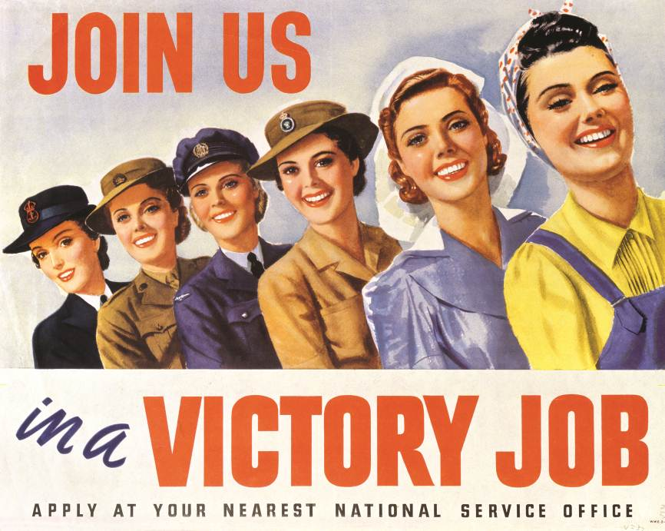

1. **Assess** how the imagery in Source 3 supports the changing role of women in Australia during World War II. Ensure you refer to the design elements of the advertisement to support your response.
2. **Evaluate** how successful you think this advertisement would have been. **Justify** your response by referring to the emotions appealed to in Source 3.

**Source 4: Excerpt from Paul Ham, ‘Kokoda’, ABC (2010) – ‘Heroics at Isurava’**

|  |
| --- |
| “The Australians had neither the numbers nor the ammunition to withstand the onslaught. They were gradually overwhelmed, but not without a string of extraordinary last stands, which yielded more Allied decorations than in any other single battle in the Pacific. These were not blind heroics; they were calculated initiatives by Australian privates, corporals and platoon commanders determined to hold off the enemy as their units withdrew.” |

**Source 5: Excerpt adapted from Peter Williams, ‘The Kokoda Campaign’ (2012)**

|  |
| --- |
| *Written in response to historical accounts that suggest that the Japanese greatly outnumbered the Australian troops:*  “The Allies […] could withdraw tired, exhausted and sick formations, and replace them with fresh ones much more often than could the Japanese. On the Kokoda Trail from July to September, during the Japanese advance, the Australians generally fought the Japanese at about one to one.” |

**Source 6 – ‘Hunting the Hunter’, J.C. Walker, 1942**

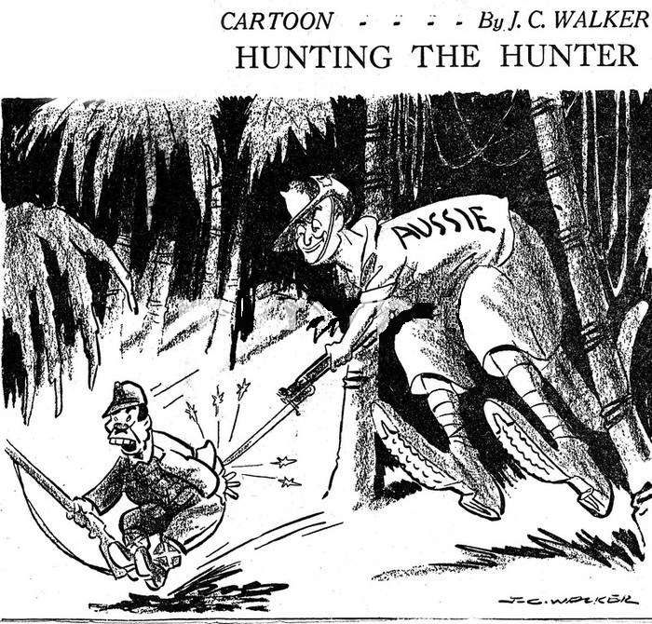

***Refer to Sources 4, 5 and 6 answer the following questions:***

1. **Explain** the different portrayals of Australia’s achievements in PNG in the two sources.
2. **Identify** the purpose of each source.
3. **Assess** both sources and **evaluate** which source is more reliable. Explain your answer.

***Refer to Sources 5 and 6 to complete the following:***

1. **Compare** and **contrast** Sources 5 and 6 in the table below:

|  |  |  |
| --- | --- | --- |
| **Aspect** | **Source 5** | **Source 6** |
| *Type* |  |  |
| *Author* |  |  |
| *Date* |  |  |
| *Purpose* |  |  |

1. Using the information collected in the table above, **explain** why historians might view Source 6 as **more reliable** than Source 5.

***If you require any additional revision, please refer to the Big Ideas chapter review questions in your textbook*** ☺

